

Optical keyboard switches

Optoelectronics (EEEN40640)
Corey Power De Jong
18342643

Mechanical switches
Traditionally, the gold standard for keyboard switches has been mechanical switches. While not having an agreed upon definition amongst keyboard enthusiasts, there is a general consensus on what conditions need to be met for a keyboard to be considered mechanical; it should have discrete switches, containing a stem which is pressed down, causing a metal leaf to contact part of the body. When the metal is contacted, current is allowed to flow, sending a signal to the microcontroller on the keyboard to register the keypress. The stem is returned to its unpressed position by a compression spring, the strength of which determines the ‘weight’ of the switch.

Mechanical switches typically come in 3 different types, differentiated by the curve of the force required to actuate them. These are tactile, linear, and clicky. Linear switches are the simplest to understand, having a force proportional to the depth pressed at any point. They tend to be seen as smoother than other switches. Tactile switches have a “bump” feeling at some point during actuation, which some users find preferable. This is usually achieved using a leaf spring and an indent on the metal contact on the stem. Lastly, clicky switches are usually adaptations of tactile switches, with the addition of some sort of mechanism for producing a loud click noise. Many people prefer this due to its satisfying feel, and sense of tradition.

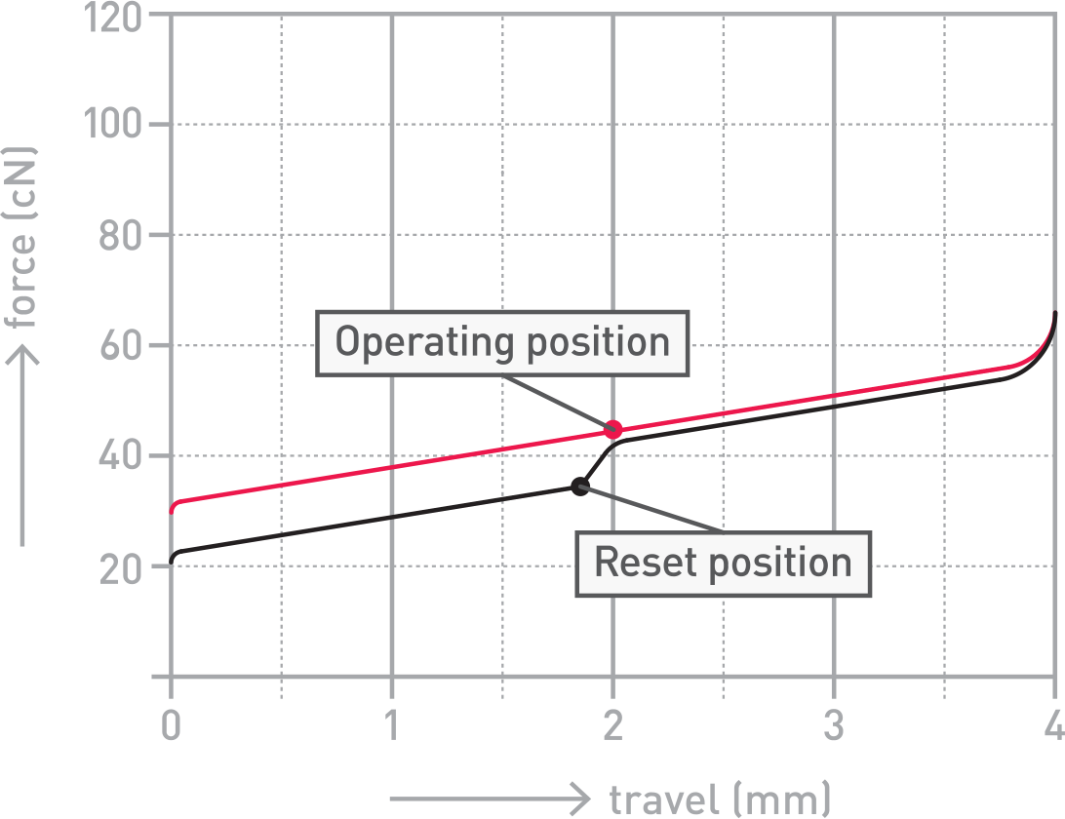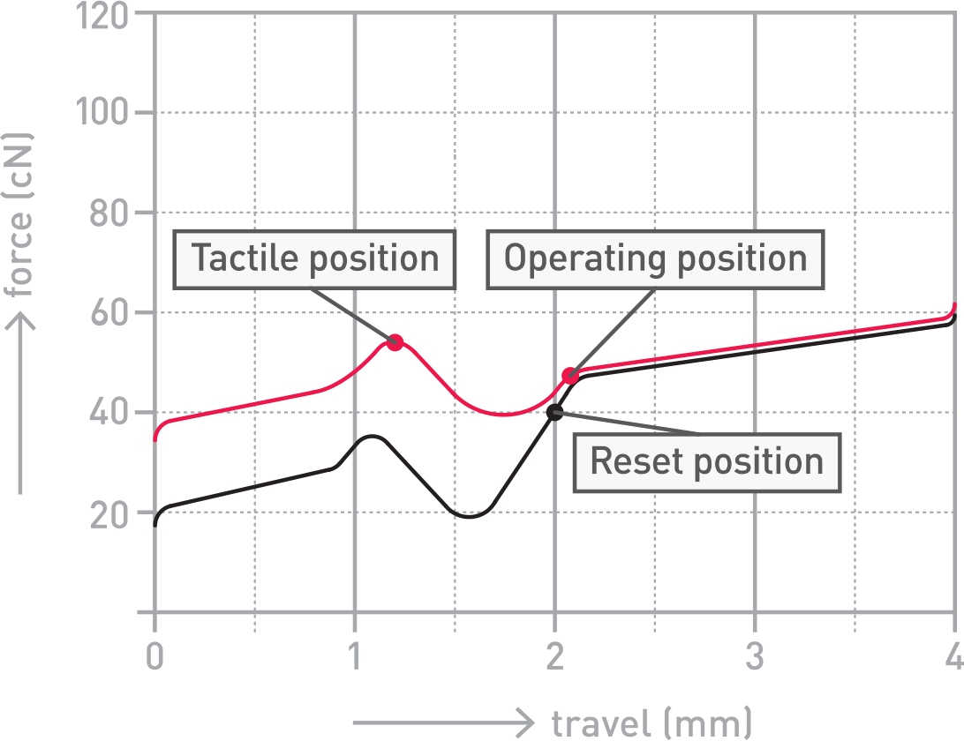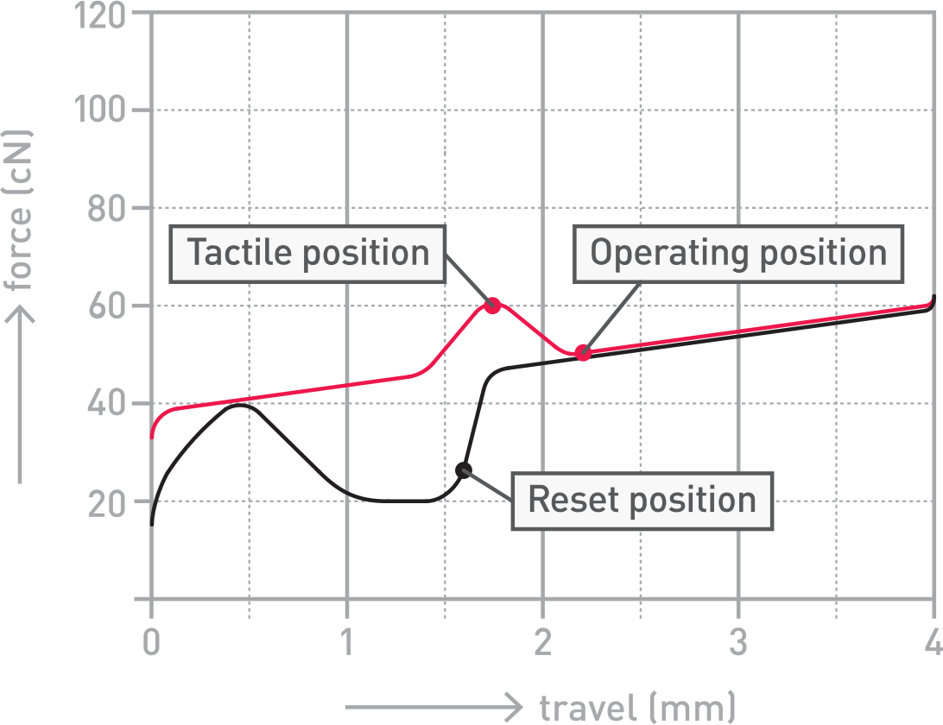
Figure 1: Force curves for linear, tactile, and clicky switches respectively.
Images taken from Cherry datasheets [1]

Tactile
Linear
Clicky

Optical switches
Optical switches have some similarities with traditional mechanical switches, but there is some contention over whether they qualify as truly mechanical switches. They tend to have stems similar to those of a traditional mechanical switch, in order to maintain usability with existing keycaps. They also have a compression spring to return the stem to the unpressed position, like traditional switches. The difference comes in the way that the keypress is detected. The switch housing contains an IR emitter and detector. When the key is pressed, the stem blocks the light from reaching the sensor, which the microcontroller in the keyboard registers as a keypress.

Optical switch manufacturers claim that their switches have many advantages over traditional mechanical switches. When traditional switches actuate, there is a small period of time when the metal contacts are extremely close, but not quite touching. During this period, current can arc between the contacts, causing oxidization of the metal contacts. Optical switch marketing material claims that this can degrade the usability of the switches over time, and reduces the lifetime of the switch. This isn’t something which occurs in optical switches, and they tend to be rated for roughly an order of magnitude more keypresses than traditional switches, in the hundreds of millions rather than the tens of millions [2]. This higher nominal lifetime is also attributed to the overall lower number of moving parts.

While major brands like Razer don’t publish datasheets for their switches, due to them being recent patented research, I tracked down an approximate parts sheet for sample budget priced switches. These included an APA3010P3BT-GX phototransistor [3][4] as a sensor, and an IR12-21C/TR8 [5][6] infrared LED as a transmitter. When a minimum of a thousand of each component is purchased, the baseline price of the switch before markup, housing moulds, or manufacturing, is approximately 20c. Projecting from these, the switches are relatively expensive when compared to budget switches which can retail for as little as 33c, if not lower.

There are also some issues around optical switches relating to compatibility. Most keyboards at present use a standard switch mounting system, meaning that enthusiasts would purchase a printed circuit board (PCB), keyboard housing, and switches, all separately and to their specification. They can then simply solder whatever switches they have chosen to the PCB without little worry that they will fit the slots. This is not the case with optical switches, which often have bespoke housing and connectors due to their unique nature and relative newness. Some companies, such as keychron have manufactured some keyboards that use replaceable optical switches [7], however they are generally not considered enthusiast grade and didn’t fully take off.

Whether or not optical switches are the future is still a topic of great debate among the keyboard enthusiast community. Many seem to like their ‘clean’ feeling, and the reliability is a big draw for users. However, the fast actuation they purport is generally not useful to the majority population. Demographics who would see the most utility of a component like these would be gamers, who need the lowest latency possible for a competitive advantage. There may be some uptake in optical switch popularity in the future, however it is hard to tell based on how the market stands at the moment.

Optomechanical switches(?)
Razer made these but they seemed to be nothing more than standard mechanical switches with some optical component inspiration.

References:
[1a]
https://www.cherrymx.de/_Resources/Persistent/b/7/a/b/b7ab2f72bd5686e1e1e759a9f3703536d7fb1e18/EN_CHERRY_MX_RED.pdf

[1b]
https://www.cherrymx.de/_Resources/Persistent/1/3/6/1/13618248706cd28e75ab9bdf9e55e9f8794611c1/EN_CHERRY_MX_BROWN.pdf

[1c] https://www.cherrymx.de/_Resources/Persistent/a/5/3/1/a531cb6598bc849cbcf131fd7a31814282b74545/EN_CHERRY_MX_BLUE.pdf

[2] https://www.razer.com/eu-en/razer-optical-switch

[3] https://www.kingbrightusa.com/images/catalog/SPEC/APA3010P3BT-GX.pdf

[4] https://www.digikey.ie/en/products/detail/kingbright/APA3010P3BT-GX/4977013

[5] https://pdf1.alldatasheet.com/datasheet-pdf/view/455255/EVERLIGHT/IR12-21C-TR8.html

[6] https://www.digikey.ie/en/products/detail/everlight-electronics-co-ltd/IR12-21C-TR8/2676085

